11.42: If Lancelot were at the end of the bridge, the tension in the cable would be (from taking torques about the hinge of the bridge) obtained from

so 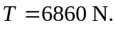 This exceeds the maximum tension that the cable can have, so Lancelot is going into the drink. To find the distance x Lancelot can ride, replace the 12.0 m multiplying Lancelot’s weight by x and the tension 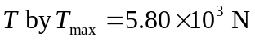 and solve for x;

